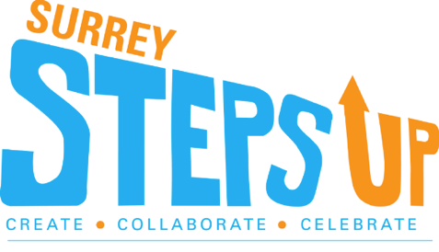
Breakout Sessions

20 MINUTE SESSIONS (PLEASE SELECT TWO)
RUNNING 1:00PM-1:20PM AND 1:10PM-1:40PM

KAHOOTS | YOUTH HELPING YOUTH – SELF CARE | Surrey Anti-Gang Family Empowerment (SAFE) - #BlockEmDontShareEm
Description  Think you know all about your community? Current events? Join us for challenging game of Kahoots and show us how much you know! | Description  Youth Helping Youth (YHY) is a not-for-profit organization made by youth for youth. We help intercity youth discover opportunities in their communities! Through our social media platforms, youth can find events, volunteer and job positions, internships, and valuable experiences  The pandemic has affected all of us youth, now more than ever. This workshop highlights self-care strategies, coping skills, supports, and resources available to youth during the COVID pandemic. | Description  #BlockEmDontShareEm  Join us for an overview of the #BlockEmDontShareEm Campaign designed to foster an understanding of the importance of not sharing intimate images online. Each of us have the power and the responsibility to “stop the spread”. Learn the implications of a viral image, as well as the legal, social and emotional consequences of spreading an image without consent. Students will gain an understanding of the role they play through positive dialogue and a pledge activity.
Materials Needed  Access to Kahoots either as a class team or as individuals | Materials Needed  None | Materials Needed  None

DEVELOPING YOUTH LEADERSHIP | PAPER EMROIDERY
Description  Youth Helping Youth (YHY) is a not-for-profit organization made by youth for youth. We help intercity youth discover opportunities in their communities! Through our social media platforms, youth can find events, volunteer and job positions, internships, and valuable experiences  This workshop will highlight tips and strategies to help youth achieve success in their careers and reach their goals. | Description  Virginia from our SSU planning team is passionate about embroidery art and would love to teach you how to make a piece of art with just a canvas and a needle and yarn! Today, it will be a different art style, I will show how to make a flower with embroidery art
Materials Needed  None | Materials Needed  - 8” x 10” artist canvas  - Yarn variety of colours  (must include black, and green yarn)  - Needle that is big enough to fit the yarn  - Stencil.  **ALL MATERIALS NEEDED WILL BE PROVIDED FOR GROUPS THAT ARE REGISTERED**

40 MINUTE SESSIONS (PLEASE SELECT ONE)
RUNNING 1:00PM-1:40PM

Young People on a Journey to Conquering a Global Pandemic- Presented by SPARK Foundation (Rochelle Prasad) | Doodle Games – Art Therapy | Surrey Gang Enforcement Team (SGET)/Diversity and Indigenous Peoples Unit
Description  Join us for a live youth panel hosted by SPARK Foundation who will share a young person's perspective on how the pandemic has affected them, how they’ve been coping with the pandemic, and what change they want to see come out of this. Ask questions, participate in interactive activities and connect with other young people. Lots of prizes to be won. | Description  Take a break from schoolwork and enjoy some creative games. This will be a live demo, led by Surrey youth where we will make and share art together. | Description  Join us for an interactive session with two Surrey RCMP members who reflect on their careers and answer your questions!! Understanding gang activity, valuing healthy relationships, or even how to pursue your own career in law enforcement.
Materials Needed  None | Materials Needed  Paper, scissors and something to write with.  No previous art skills required. | Materials Needed  None

