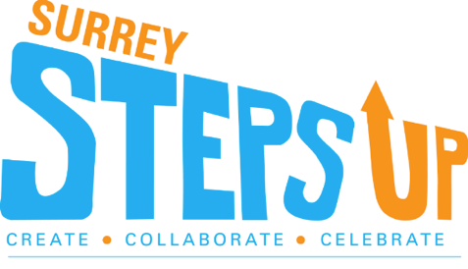

**AGENDA**

12:30pm                           Event Kick Off

12:40pm              Recognition of the 2021 SSU youth and groups who have “stepped up!”

12:55pm                            Keynote Speaker:

Rochelle Prasad –

Spark Foundation

1:00pm                              Break-Out Sessions

(pre-registration required)

1:40pm                              Return to main event for prizes & wrap up!